**Annasaheb Dange College of Engineering**

**And Technology, Ashta.**



**A Report On**

**“VOICE ASSISTANT USING PYTHON”**

**By**

**Ms. Najiya Salim Mulla.(20131066)**

**Roll No: 3151**

**Submitted To Department of**

**Computer Science and Engineering**

**Under the Guidance of,**

**Prof. Mr.Yogesh Lubal**

**2022-23**

* **Introduction:**
* It is a software that carries out everyday tasks via voice command.
* The query for the assistant can be manipulated as per the users need.
* Python provide an API module called SpeechRecognition to allow us to convert audio into text for further processing.
* **Abstract:**

Today the technological advancement is increasing day by day. Earlier only there was a computer system in which we can do only few tasks. But now machine learning, artificial intelligence, deep learning, and few more technologies have made computer systems so advance that we can perform any type of task. In such era of advancement if people are still struggling to interact using various input devices, then it’s not worth it. For this reason, we developed a voice assistant using python which allows the user to run any type of command in linux without interaction with keyboard. The main task of voice assistant is to minimize the use of input devices like keyboard, mouse etc. It will also reduce the hardware space and cost.

* **PROBLEM STATEMENT:**

The problem is to design a Voice Assistant Using Python to carries out everyday tasks via voice commands

* **Modules:**

1. **Pyttsx3:-** This module is used for the conversion of text to speech in a program it works offline. To install this module type the below command in the terminal.  
   **pip install pyttsx3**
2. **Tkinter:-** This module is used for building GUI and comes inbuilt with Python. This module comes built-in with Python.
3. **Wikipedia:-** As we all know Wikipedia is a great source of knowledge just like GeeksforGeeks we have used the Wikipedia module to get information from Wikipedia or to perform a Wikipedia search. To install this module type the below command in the terminal.

**pip install Wikipedia**

1. **Speech Recognition:-** Since we’re building an Application of voice assistant, one of the most important things in this is that your assistant recognizes your voice (means what you want to say/ ask). To install this module type the below command in the terminal.

**pip install SpeechRecognition**

1. **Web browser:-** To perform Web Search. This module comes built-in with Python.
2. **Pyjokes:-** Pyjokes is used for the collection of Python Jokes over the Internet. To install this module type the below command in the terminal.  
   **pip install pyjokes**
3. **Datetime:-** Date and Time are used to showing Date and Time. This module comes built-in with Python.
4. **WolframAlpha:-** It is used to compute expert-level answers using Wolfram’s algorithms, knowledgebase and AI technology. To install this module type the below command in the terminal.

**pip install wolframalpha**

* **Objective:**
* It can help to increase productivity in many bussiness,such as in healthcare industries.
* It can capture speech much faster than you can type.
* You can use Text to speech in real-time.
* Helps those who have problems with speech or sight.
* It control your device with spoken commands so you can open apps, navigate,and edit text hands-fress.
* **FUTURE SCOPE:**

**Technological advances are making voice assistants more capable, particularly in AI, natural language processing (NLP), and machine learning**. To build a robust speech recognition experience, the artificial intelligence behind it must become better at handling challenges such as accents and background noise.

* **Conclusion:**

We developed a voice assistant using python which **allows the user to run any type of command in linux without interaction with keyboard**. The main task of voice assistant is to minimize the use of input devices like keyboard, mouse etc. It will also reduce the hardware space and cost.

* **Output:**

1)

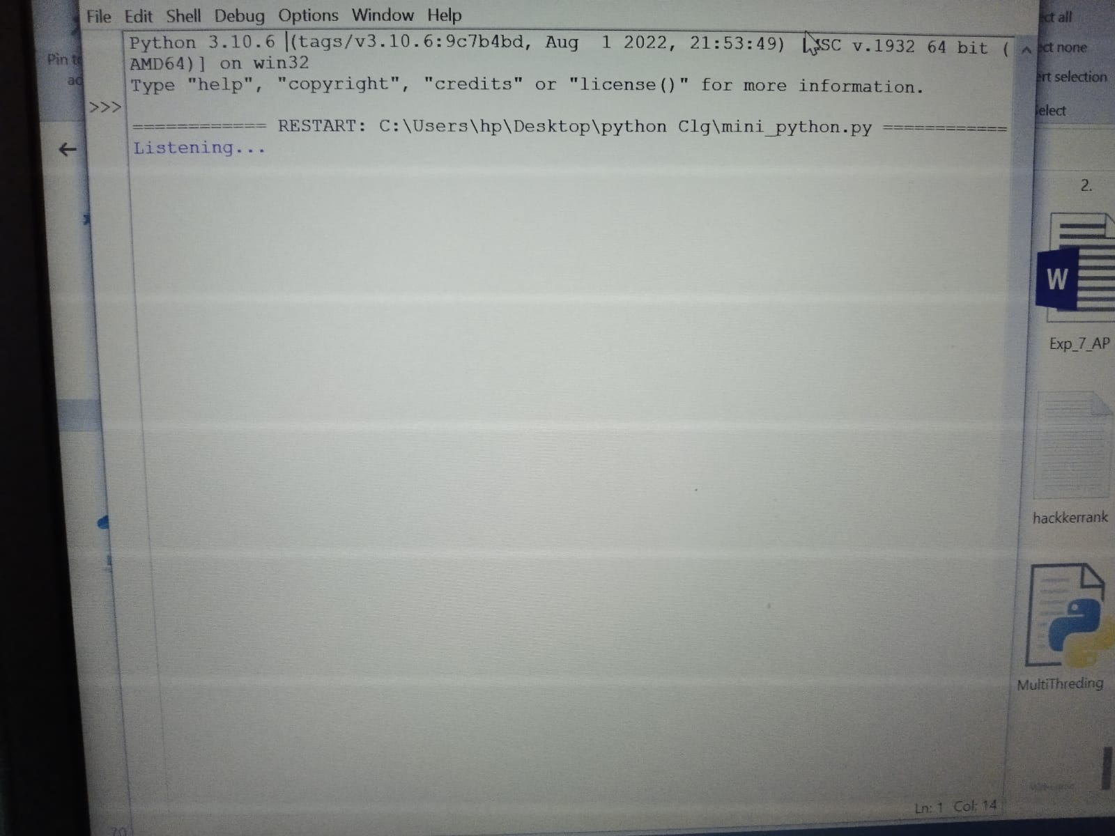

2).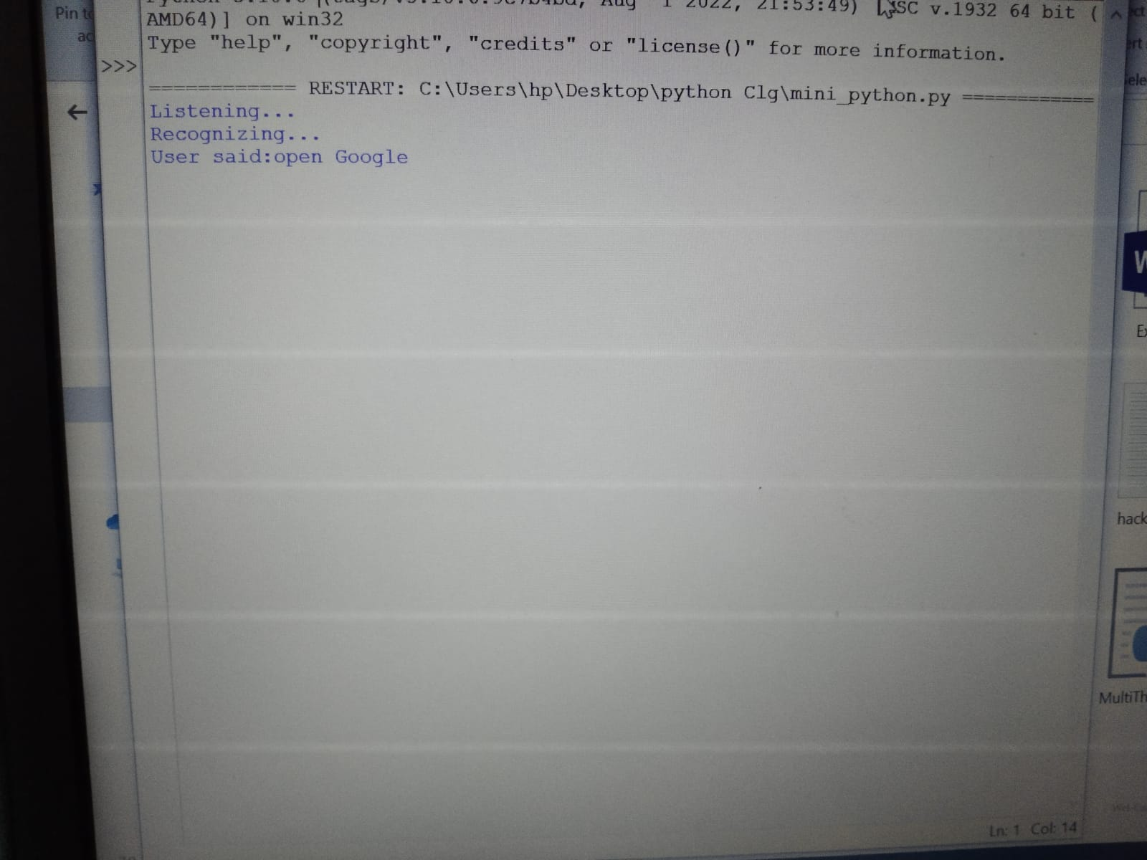

3).

4).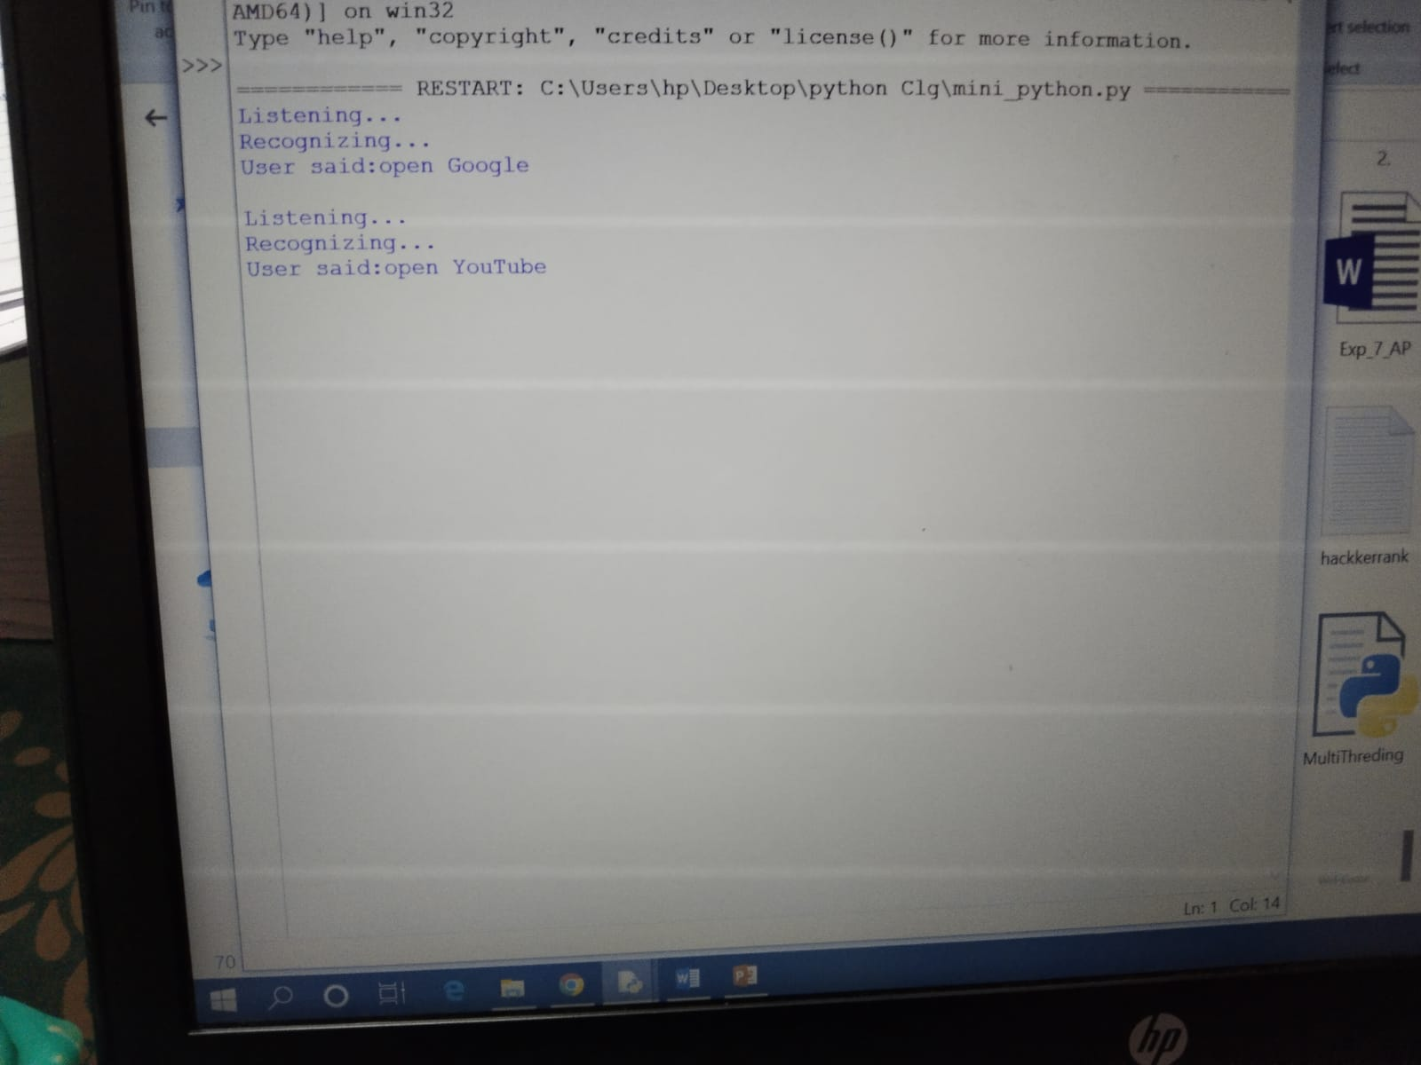

5).



6).

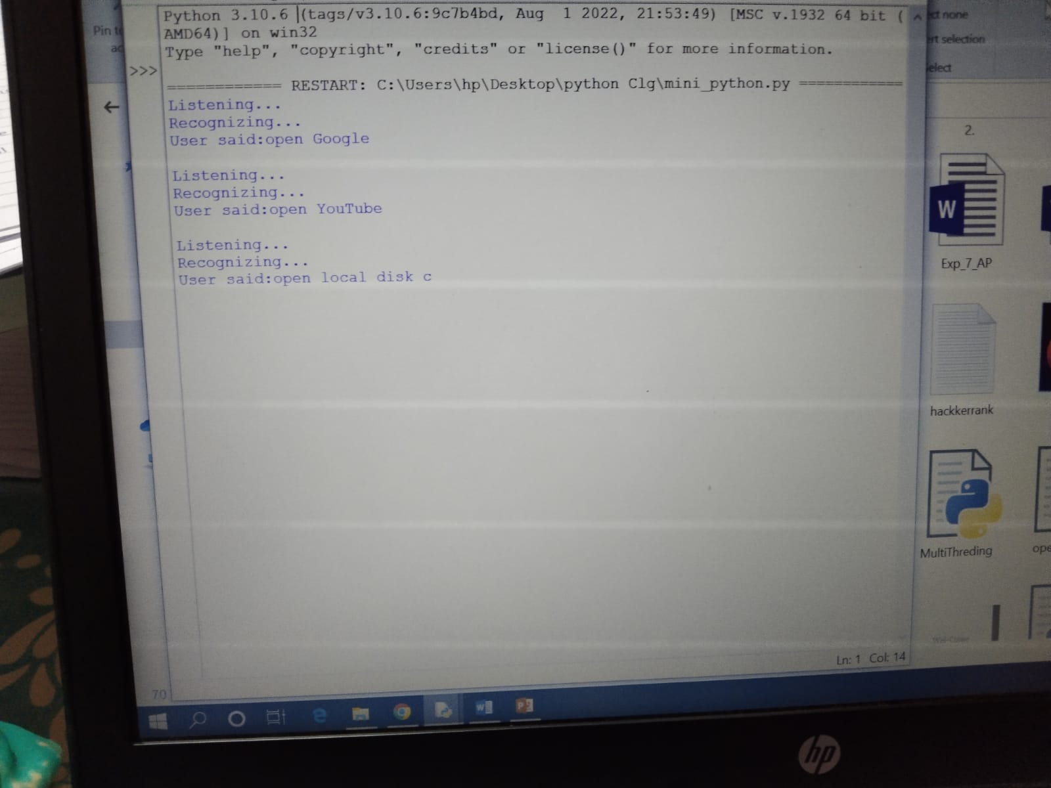

7). 